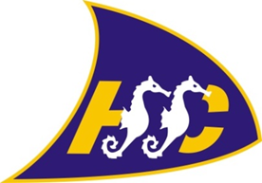

HYTHE & SALTWOOD SAILING CLUB
Winch Operation Training Log
Updated 1.1.23

Person Trained: …………………………………………………..

Operator Delivering Training: …………………………………………………..

Date of Training: …………………………………………………..

Winch operation/safety checks. The Race Officer and Rescue Boat crew are the only people who manage the winching of the club rescue boat, with the Race Officer of the day taking the leadership role.

All other club members boats are winched at the member’s own responsibility. Nobody is allowed to operate the winch alone and if they have not agreed to sign up to this safety training, it is not the responsibility of the club to ensure their safety.
 | Instructor Initials | Training Completed (tick to confirm) | Comments
Checking winch lines, hook eye & attachment of karabiner onto trailer
Ensuring promenade is clear of boats directly in front of the winch area for clear vision and safety signage is displayed
Ensuring Race Officer is not distracted when operating winch – no mobile phones
Correct use of commands such as ‘clear’, ‘stop’ & ‘winch’ rather than go, no and woah
Ensuring there is always someone assisting with winch operation on the beach - banksman
No more than two dinghies on one tow line at any time
Stop winch operation at any time if anyone/thing presents a possible danger
Put away winch and line safely at end of usage.

