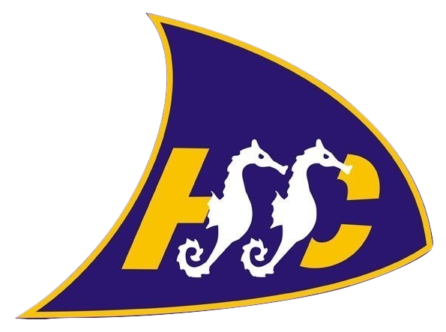

Hythe & Saltwood Sailing Club

Committee Members Register of Interests
Updated 1.1.23

Recognising – Committee Members must always act in the best interests of the club and as such should disclose any current or potential conflicts of interest upon election at the AGM. Committee Members are responsible for notifying the Committee of any changes to their conflicts of interest. Changes should be notified either in a Committee Meeting where it can be minuted or directly to the Secretary.
Recording – The form below shows current and potential conflicts and should be updated with every change.
Managing – Action must be taken by the Committee if a conflict of interest arises. This might involve excluding a Committee Member from a decision-making process or a meeting. Any actions should be recorded below.
Committee Member | Description of Interest | Date of Disclosure | Has the wider committee been notified of the interest? | Steps taken by committee / individual for dealing with the conflict

