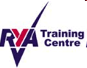
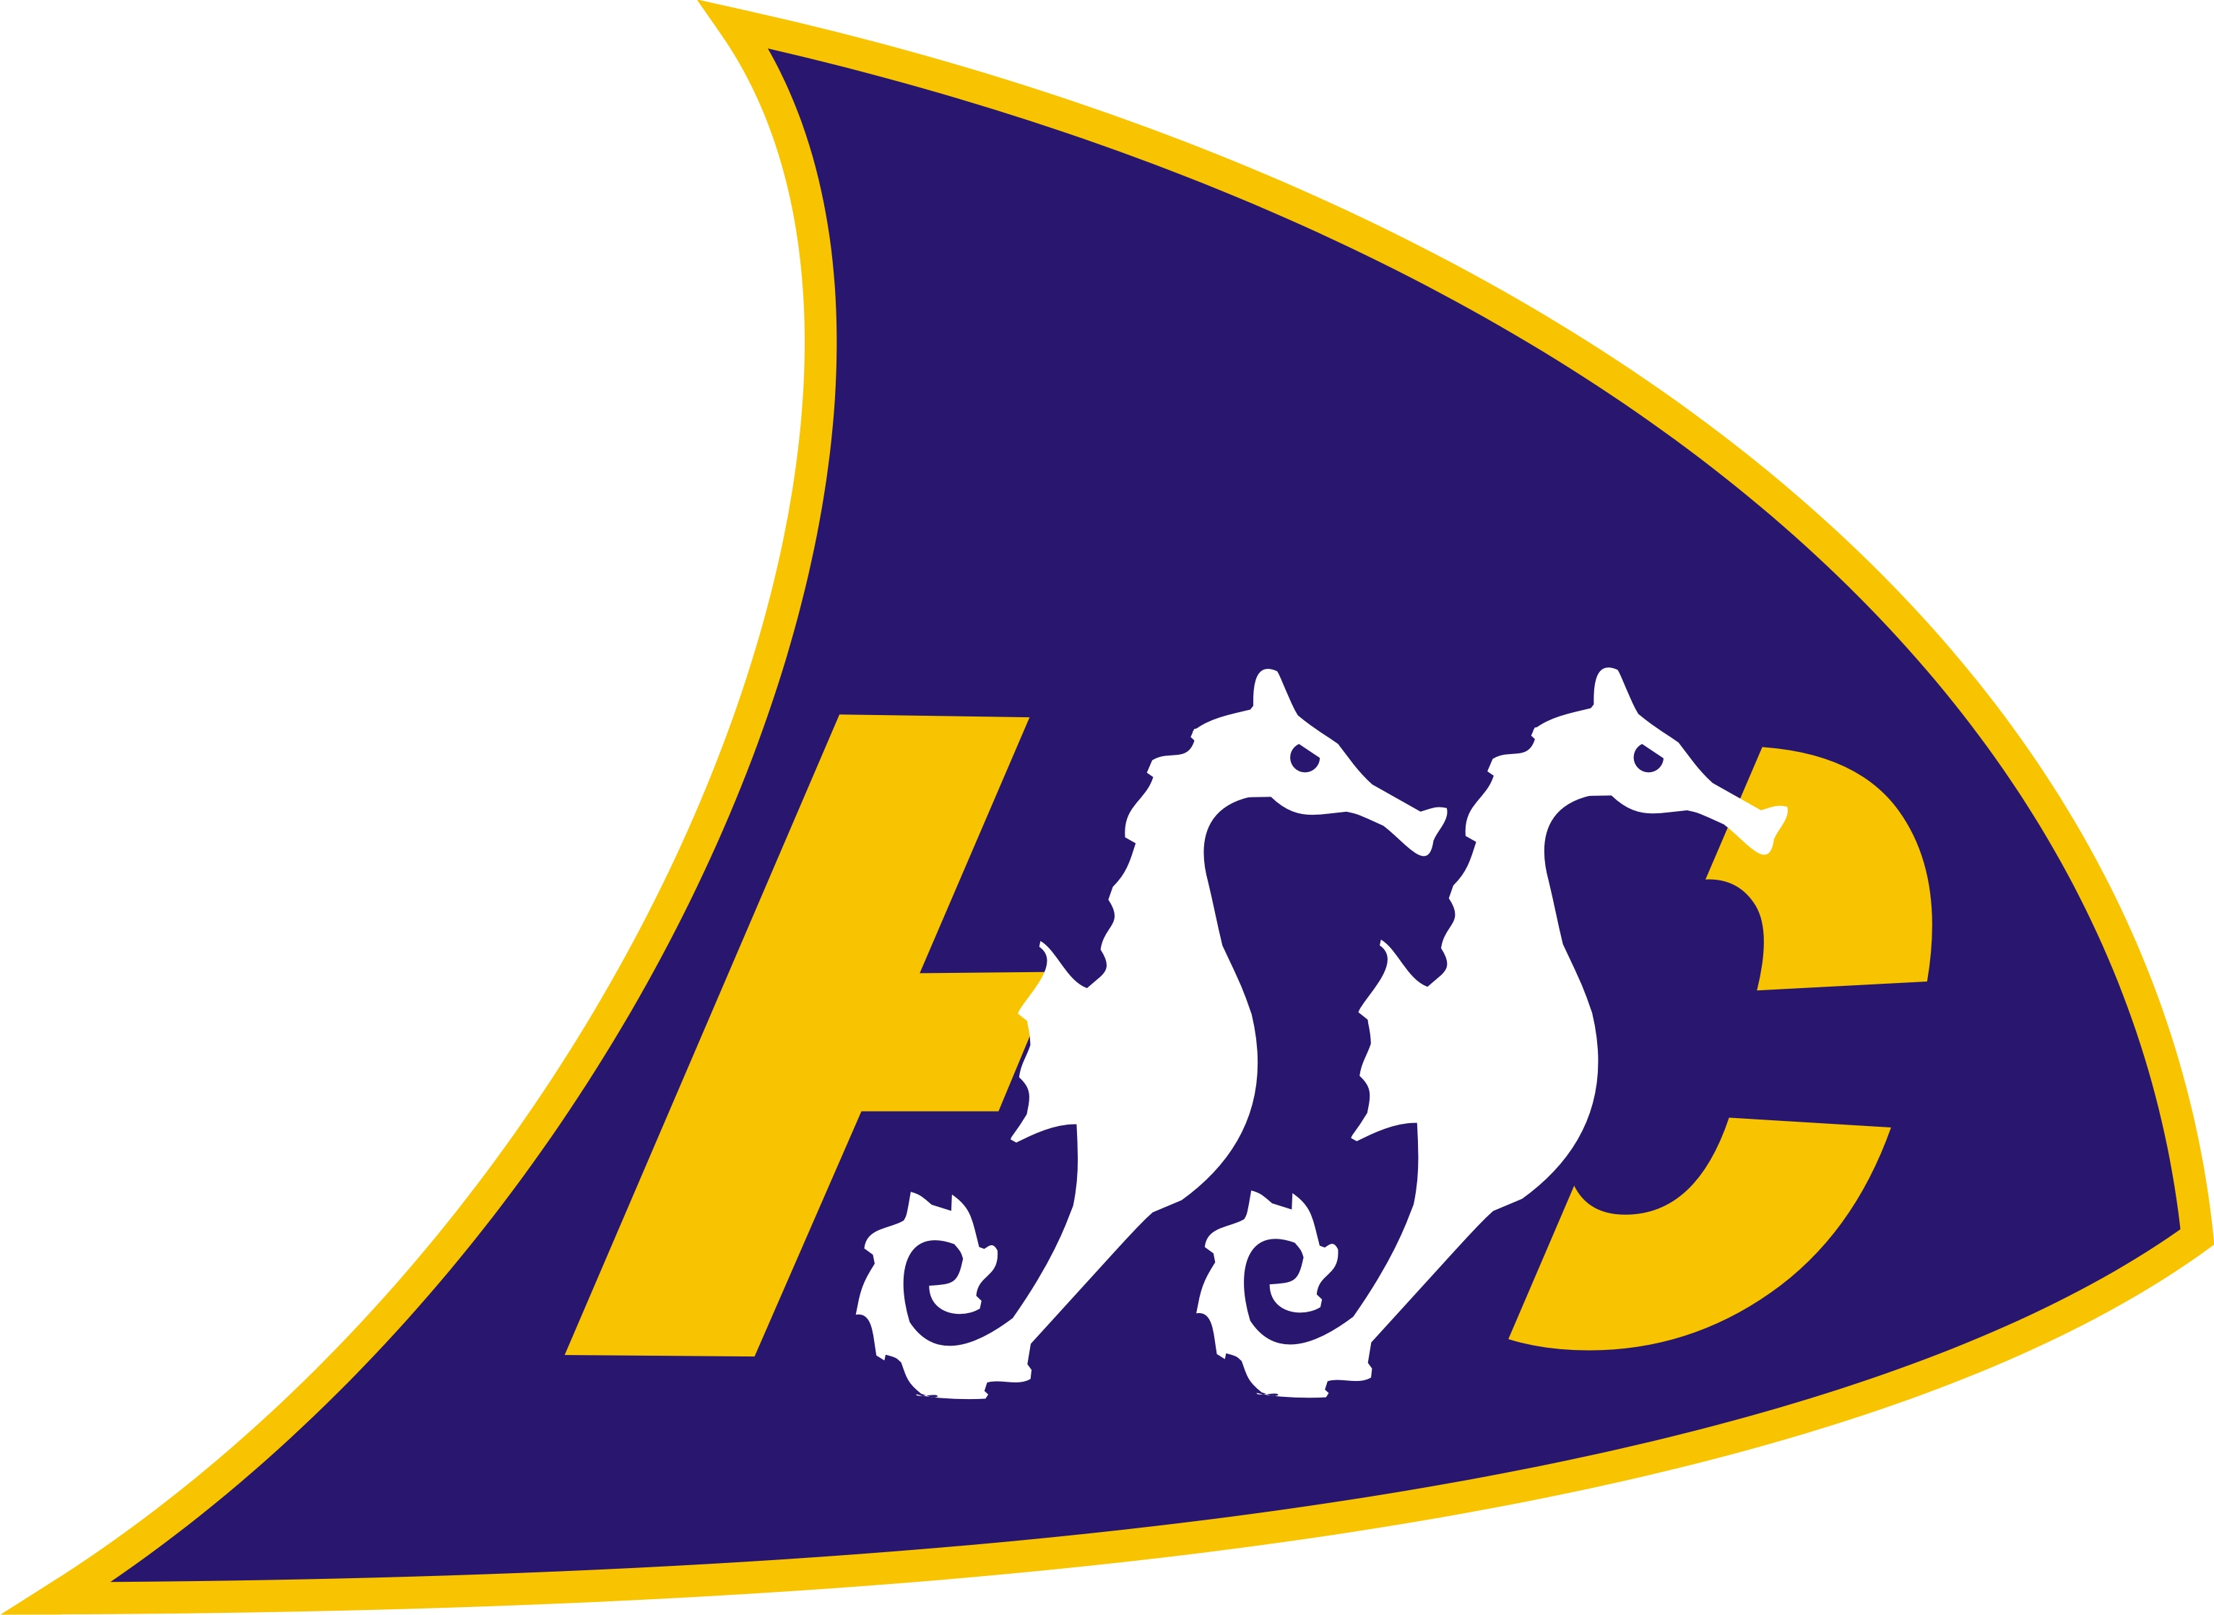
Hythe and Saltwood Sailing Club
Safety Boat Refresher Training Log
Person Trained: …………………………………………………..
Operator Delivering Training: …………………………………………………..
Date of Training: …………………………………………………..

 | Instructor Initials | Training Completed (tick to confirm) | Comments
Safety boat (RIB) operation/safety overview.

Running up engine, preparing RIB for sea
1st aid and safety. Preparing race buoys, chains, anchors.
Ensuring Race Officer is in radio contact with RIB crew. Test radio operation.
Manual handling of RIB from garage to beach and launching.
Safe launching RIB.
Safe driving of Rib, laying race buoys, operation, MOB, rescue of dinghy.
Safe landing of RIB.
Removing RIB from sea- Checking winch lines, hook eye & attachment of karabiner onto RIB trailer
Flushing out engine, turning off fuel/power/turning engine to house steering arm, putting away the RIB safely at end of usage.

