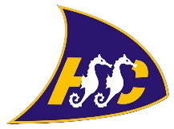

Hythe & Saltwood Sailing Club Training

Learn to Windsurf Again!
A six week course starting Saturday 13th May 2017 10am to noon.

If you wish to attend any course then complete and return the form below to:

Marc Carney – training@hssc.net
or Hythe & Saltwood Sailing Club, Marine Parade, Hythe, Kent, CT21 6AW

Forms should be completed and returned prior to the training event as spaces with be allocated on a
first come first served basis.

-----------------------------------------------------------------------------------------------------------------------------
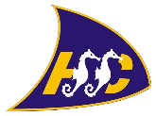
Hythe & Saltwood Sailing Club - 2017
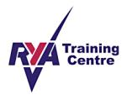
Windsurfing Training Declaration/Registration Form
Surname: |  |  | Title:
Forename: |  |  | Date of Birth:
Address:

Email: (future correspondence will be by email)

Course: | Date/Time: |  |  | Fee:
I enclose full payment of:  (Cheques payable to Hythe & Saltwood Sailing Club) |  | £
Emergency Contact: |  | Telephone No:
Details of any medication or medical treatment being received (if none, write none)

I declare that to the best of my knowledge I am not suffering from epilepsy, disability, giddy spells, asthma, diabetes,
angina or any other heart condition. I am fit to participate in the course and I am water confident. I agree to abide by
the rules of Hythe & Saltwood Sailing Club.
Signature: |  |  | Date:
The Small Print
Deposits or monies equivalent too, are non refundable should cancellation by yourself be within 4 weeks prior to the commencement of the course.
Should we (HSSC) cancel the course then participants will be offered an alternative date or given a full refund. No refunds shall be given after the
commencement of the course.
RYA Instructors, RYA Senior Instructors or RYA Coaches do not accept responsibility for any loss, damage or injury suffered by persons and/or their property arising out of or during the course of their activities whilst training and/or coaching and/or instructing unless such injury loss or damage was caused by, or resulted from negligence or deliberate act.

