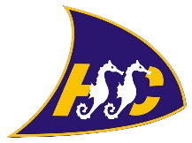

Hythe & Saltwood Sailing Club Training

Push the Boat Out Training Form

To take part in our Push the Boat Out Weekend, please complete the below form for each individual
participant and return it to

Tony Wyatt at – training@hssc.net
or Hythe & Saltwood Sailing Club, Marine Parade, Hythe, Kent, CT21 6AW

Forms should be completed and returned prior to the training event as spaces with be allocated on a
first come first served basis.

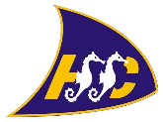
Hythe & Saltwood Sailing Club - 2017
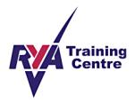
Push the Boat Out Declaration/Registration Form
Surname: |  |  | Title:
Forename: |  |  | Date of Birth:
Address:

Email: (future correspondence will be by email)

Course: (circle as appropriate)  Sailing / Windsurfing / Kayaking / SUP | Date/Time: (circle as appropriate)  13th May 2017 / 14th May 2017
Emergency Contact: |  | Telephone No:
Details of any medication or medical treatment being received (if none, write none)

I declare that to the best of my knowledge I am not suffering from epilepsy, disability, giddy spells, asthma, diabetes,
angina or any other heart condition. I am fit to participate in the course and I am water confident. I agree to abide by
the rules of Hythe & Saltwood Sailing Club.
Signature: |  |  | Date:
The Small Print
RYA Instructors, RYA Senior Instructors or RYA Coaches do not accept responsibility for any loss, damage or injury suffered by persons and/or their property arising out of or during the course of their activities whilst training and/or coaching and/or instructing unless such injury loss or damage was caused by, or resulted from negligence or deliberate act.

